TEMPLATE
Time Series investigation
(Line graph)

Explore data using a statistical inquiry process (Internal)
NCEA Level 1

AS 91944
5 credits



1. Problem

How to use this template
For the 1.1 assessment, you will complete an investigation and write a report. The report you write will follow the PPDAC structure.
- Problem
- Plan
- Data
- Analysis
- Conclusion
If you are using this template, you have chosen to investigate how one numerical variable changes over time, using a line graph.
In the green boxes there is space for you to complete your report. The sentence starters are there to guide you, but you don’t have to use them.
In the red boxes there is an example report, written to excellence level.
The text that has been written in orange is key information to include for excellence, but may not be strictly necessary for students just trying to pass.
Investigative Question:
This report will investigate the change in [numerical variable (unit)] each [unit of time] between [start] and [finish].
This report will investigate the change in the number of Australians entering New Zealand on a visitor’s visa each quarter from 2000 to 2019 using the NZGrapher Dataset (source: Statistics New Zealand).

Background/purpose:
- What made you interested in studying this investigation?
- What is the purpose of the investigation - who will it be useful for?
- How widely could your results be applied?
For excellence, also include evidence of outside research.

I chose to do this investigation because at the moment, immigration is a popular topic on the news, and lot of NZ’ers have been immigrating to Australia (net migration loss of 30,000 people in 2024). It made me wonder if holiday visitor numbers from Australia to NZ are also going down.
The results could be useful for Tourism NZ. If they notice that numbers from Australia are starting to slump, they might like to have a targeted advertising campaign to try encourage Aussies to visit NZ. It’ll also be useful for Tourism NZ to see what time of year Aussies tend to come to NZ, which might help them time their advertising campaigns as best they can.
The results might also be useful for economists, because there is a relationship between exchange rates and visitor numbers according to sources (https://img.scoop.co.nz/media/pdfs/0707/extoursuum.pdf.pdf). This could help them make predictions about future exchange rates.
One difficulty with extending the results to today is that the data only goes up to 2019. Visitor/tourist habits changed a lot during lockdowns and right afterwards (according to sources like https://www.nature.com/articles/s41562-024-02037-w) , so the data from 2000 to 2019 might not be relevant for predicting tourism habits today, post-Covid.
Hypothesis:
- What might you expect to find in your investigation, and why?
I’m expecting that the trend in [numerical variable] will have [increased/decreased/remained steady] from [start] to [finish].
This is because…
I’m also expecting that the highest [period e.g. year, quarter, month, etc] for [numerical variable] will be [period].
This is because…

I’m expecting that the trend in the number of Australians entering NZ on a tourist visa will have increased consistently between 2000 to 2019.
This is because the general population of both Australia and NZ have been increasing during this period, so it makes sense that tourism has also increased.
I’m also expecting that the most popular quarter for Australians to visit NZ will be Quarter 1.
This is because Jan/Feb/March are the hottest months in NZ (https://newzealandtrails.com/news/best-time-to-visit-new-zealand). Traditionally people like to go on holiday just after or around Christmas.
I’m expecting that the least popular quarter will be quarter 3 (July/August/September).
2. Plan
Collection of data
- What source did you get the data from, or how did you collect it (and was it collected fairly/properly)?
- Is the data likely to be reliable?

The dataset is from the NZGrapher ‘Visitors’ dataset. It is real data collected by Statistics NZ between 2000 and 2019.
Given that Statistics NZ is a government institution, we can expect that the data would have been collected reliably and a representative sample would have been obtained.

Cleaning the data
- Was any ‘cleaning’ of the data required? (‘Cleaning’ is only required for data which was obviously recorded wrong or was incomplete).

No cleaning of the data was required because there wasn’t any incomplete data, and none of the data appeared to be incorrectly recorded.

Sources of variation
- Discuss at least two of the following sources of variation:
  - Natural/real variation
  - Occasion-to-occasion variation
  - Measurement variation
  - Induced variation
  - Sampling variation (only if you took a sample)
- How did you manage those sources of variation?

There might have been measurement variation. This is the variation that occurs because there might be differences in how the number of Australian visitors is measured.
For example, it might be possible that in one year they counted an Australian visitor as anyone who had an Australian passport. However, it another year they might have counted an Australian visitor as anyone who had Australian residency. These changes in what ‘counts’ as an Australian visitor can cause variation from year to year. Because Statistics NZ has a good reputation, we can assume they have controlled this variation by making sure the definition of ‘Australian visitor’ stays the same from year to year.
Another type of variation is sampling variation because, when Statistics NZ collected the data, they used sampling in order to do so. Sampling variation means that it is possible that, if Statistics NZ collected another sample of the population, the results could be different. However, again we can put a lot of trust in Statistics NZ to control this variation by taking a very large sample to reduce sampling variation.

3. Data
For help with drawing the graph on NZGrapher, see here. However, note that in addition to the graph created by Liz Sneddon in the video, you should also create:
- A seasonal effect graph by ticking ‘Seasonal (STL)’ on NZGrapher; and
- A forecast graph, which you do by creating a completely separate graph under the graph type ‘Time Series – Forecasts’.
Copy and paste your Line graph, STL graph, and forecast graph from NZGrapher (or other) here. Make sure it includes:
- a title;
- labels on each axis;
- units on the x-axis and/or y-axis;
- coloured dots (tick ‘Seasonal’ and ‘Show dots’)
- long-term trend (tick ‘Long Term Trend (STL)’)
- start & end points (tick ‘Start / End Points’).

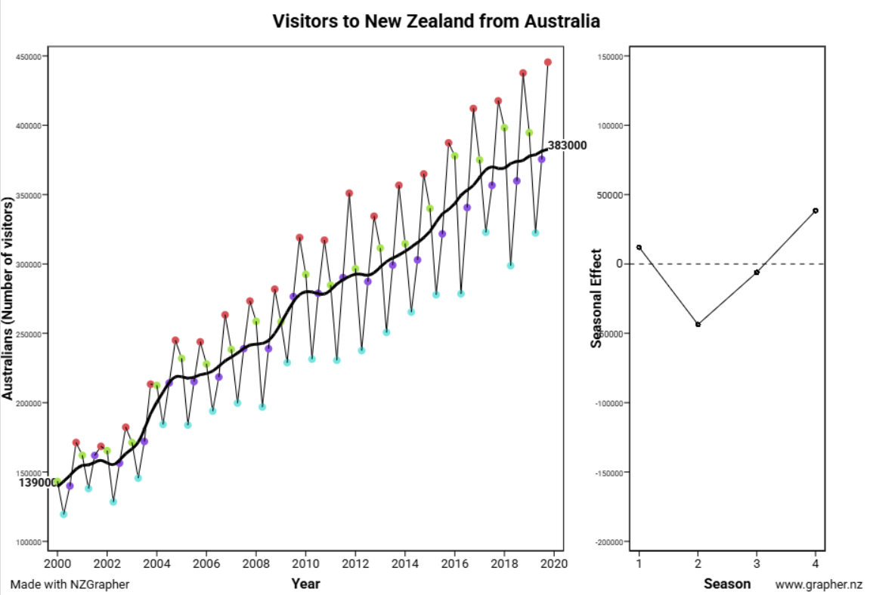
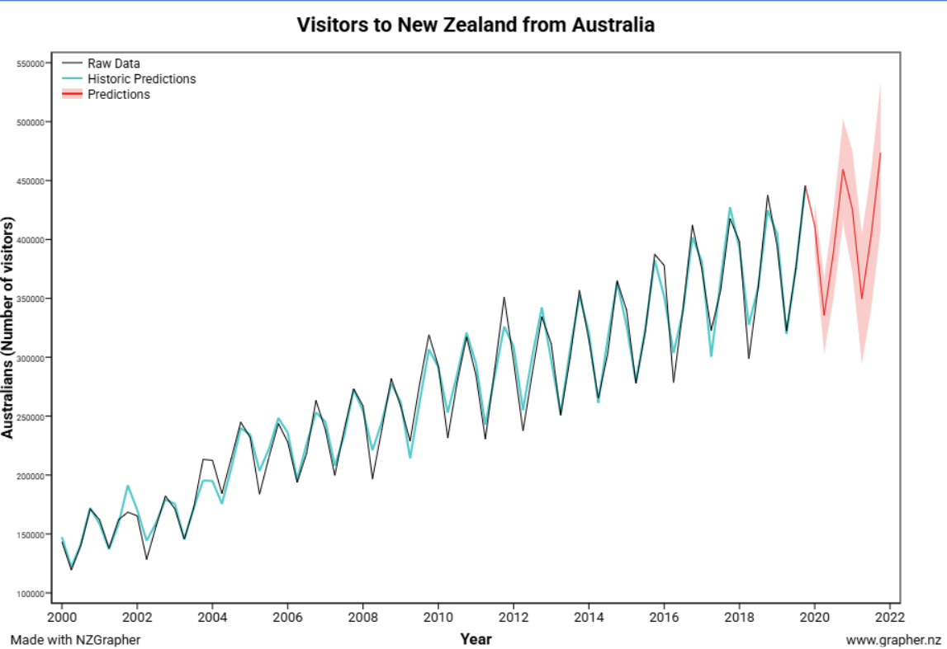

4. Analysis – Line graph – Time Series
Trend:
For trend, I notice that the first data point is on [date 1] with [X]. The final data point on [date 2] with [Y]. This shows an [increasing/decreasing/neutral] trend, with an [increase/decrease] of [Z] from [date 1] to [date 2].
Also discuss in detail any trend changes between the start and finish.
(optional) This [is/is not] what I expected because…
(optional) This [makes sense/does not make sense] because…

For trend, I notice that the first data point is on Quarter 1, 2000 at 139,000 Australian visitors to NZ. The final data point on Quarter 4, 2019 is 383,000. This shows an increasing trend across the period, with a significant increase of 244,000 from 2000 to 2019.
Within the period the increasing trend was fairly consistent throughout the period. However, there were some particularly sharp spikes in 2003-2004 (172,015 in 2003 Q3 to 214,168 in 2004 Q3) and 2008-2009 (238,895 in 2008 Q3 to 276,482 in 2009 Q3). The sharp increase in 2004 could have been due to a bounce back from the 2003 RWC, which was initially supposed to be hosted in NZ & Aus but got moved to Aus (https://www.theguardian.com/sport/2020/aug/11/new-zealands-strong-arm-tactics-evoke-memories-of-2003-rugby-world-cup-debacle). The sharp increase in 2009 could have been due to a bounceback from the 2008 financial crisis, which would have temporarily stopped people from going on holidays because of the uncertainty.

Seasonality:
I notice that there [is/is not] seasonality in the data.
If so: There is a repeating pattern where the [numerical variable] spikes during [period(s)] and dips during [period(s)].
(optional) This [is/is not] what I expected because…
(optional) This [makes sense/does not make sense] because…

I notice that there is seasonality in the data.
There is a repeating pattern where the number of visitors from Australia to NZ spikes during Q4 of each year and dips during Q2.
This makes sense, however, it is not quite what I expected because I had thought that Q1 would be the most popular period and Q3 would be the least popular period. I must have underestimated how many people travel in December (around Christmas time), perhaps New Zealanders returning home from Aus to see family.
Unusual Features:
- Any outliers?
- Any changes in variation?
- Any unexpected spikes/troughs/movements?

I notice there is change in variation as the years go on. For example, from Q2 to Q4 2002, the number of visitors from Aus increases by 53,806. However, from Q2 to Q4 2018, the number of visitors from Aus increases by 139,005. This suggests that people’s travel habits might be changing, so that they are now much more likely to do their travel in the summer months and stay in Aus during the Winter months.

Forecast:
I have created a Timeseries – Forecast Model using NZGrapher which will help enable me to make a prediction for what the number of [numerical variable] might be in the future.
Using this, in [period in the future] the forecast for the number of [numerical variable] is [X].
The 95% confidence interval means that we can be reasonably confident that the number of [numerical variable] in [period in the future] will be between [Y] and [Z].
I have created a Timeseries – Forecast Model using NZGrapher which will help enable me to make a prediction for what the number of Aus visitors to New Zealand might be in the future, after 2019.
Using this, in 2021 Q4, the forecast for the number of Australian visitors to New Zealand is 473,440.
The 95% confidence interval means that we can be reasonably confident that the number of Australian visitors to New Zealand in 2021 Q4 will be between 414,440 and 537,640.

5. Conclusion
Summary of analysis:
- Repeat investigative question.
- Summarise analysis.
My investigation was into the change in [numerical variable (unit)] from [start] to [finish] out of all [population].
Overall, this investigation concludes that there was a… [describe trend & seasonality].
My investigation was into the change in the number of Australians entering New Zealand on a visitor’s visa each quarter from 2000 to 2019 using the NZGrapher Dataset (source: Statistics New Zealand).
Overall, this investigation concludes that there has been an increasing trend from 2000 to 2019, which has been fairly consistent except for more sudden spikes in 2003-2004 and 2008-2009. There is seasonality, with the NZ summer months being most popular to travel (particularly Q1) and the winter months being least popular (particularly Q2).

Reflection:
- Was your hypothesis correct? Why or why not?
- What reflections do you have on the process?
- What else would be interesting to investigate (connected to what you investigated)?
- Are there any limitations to your investigation (and how widely your results can be extended)?
NOTE: This ‘reflection’ part is an important part of the criteria for getting excellence in this assessment. Try to show a deeper understanding of your results, think carefully about how they could actually be used, and talk about what biases/limitations might be at play.

Overall, my hypothesis was correct about the trend and seasonality, except I predicted that the peak would be in Q1 of each year, rather than Q4. As mentioned earlier, I must have underestimated how many people travel in December (around Christmas time), perhaps New Zealanders returning home from Aus to see family.
In the future, it would be interesting to investigate the reasons for Aus travel behaviours. My analysis helped track the trend, but not the reasons for the trend. For example, it could be interesting to do a bivariate investigation looking at the relationship between the average temperature in New Zealand for a given month (°C ) and the number of visitors from Australia in that month. This could help Tourism NZ understand whether Australians are mainly motivated by weather in making travel decisions, or whether there could be other factors at play.
One reflection I have on the process is that it might have been better to obtain updated data on travel numbers from Australia (up to 2026). This is because the data I’ve analysed cuts off right before Covid-19, which massively changed travel habits according to sources (https://www.nature.com/articles/s41562-024-02037-w). This makes it difficult to make a reliable forecast using the data, as both the trend and seasonality could have been massively disrupted by Covid-19.
Some limitations for this analysis is that, because it only looks at Australia, it might not be useful for the NZ Government and/or tourism industry to make any conclusions about the travel habits of any other country. Some countries, like China for example, have actually decreased their travel to NZ in the last decade (https://www.mbie.govt.nz/dmsdocument/30939-immigration-options-to-support-government-priorities-proactiverelease-pdf).

